KS1 (Years 1 and 2) Spring Term 1 Homework. Great fire of London
The blue boxes show homework suggestions for the Spring Term. Choose one or two projects to work on in depth or
dip in and try a range of the projects. The green boxes show activities your child can work at on a regular basis.

The children will have the opportunity to share their homework during the week beginning 11th February.
Daily/ regular homework task.  - Work on rapid recall of number bonds/facts up to 20 (addition and subtraction).  - Learn times tables. Start with working on solving them and then on rapid recall. | Daily/ regular homework task.  - Reading, book talk between child and parent, book reviews and written retellings of the reading book. Fill in your reading record. | Daily/ regular homework task.  - Read and spell Common Exception Words- see blue sheet.  - Work on learning to spell numbers to 20, days of the week & months of the year.
Art  Paint a scene of the Great Fire of London. What colours are you going to use for the fire and the houses?  Design your own information poster, explaining what happened during ‘The Great Fire of London’.  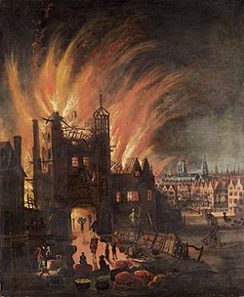 | 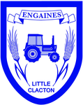  Please can all homework be in by Monday 11th February. Thank you. | Design and Technology  Design a new bakery for Thomas Farriner.  Make an apron for a baker. What materials will you use?  Make a model of your own bakery.  Get together with everyone within your household and create a fire escape plan. Check that the smoke alarms in your homes work and contact the local fire service if you need an alarm fitting.
Literacy  Write a short description of ‘The Great Fire of London’.  Write some questions you would like to ask Samuel Pepys. What would you like to know about ‘The Great Fire of London’?  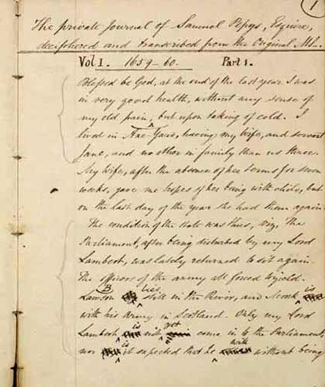  Write a diary entry as Samuel Pepys. | Science  Design a healthy lunch box- it needs to include a variety of the food groups including fruits and vegetables.  The buckets used in the Great Fire of London were made of leather, but these often leaked/ spilled the water. Is there a better material to use?  Can you conduct an experiment at home, which gives you an answer? Take pictures and write a report to show evidence. | Maths  Create a tally chart. How many of your friends and family can tell you something about the Great Fire of London?  Find some objects in the kitchen and weigh them. Which are the heaviest? Which are the lightest? Are any an equal weight?

